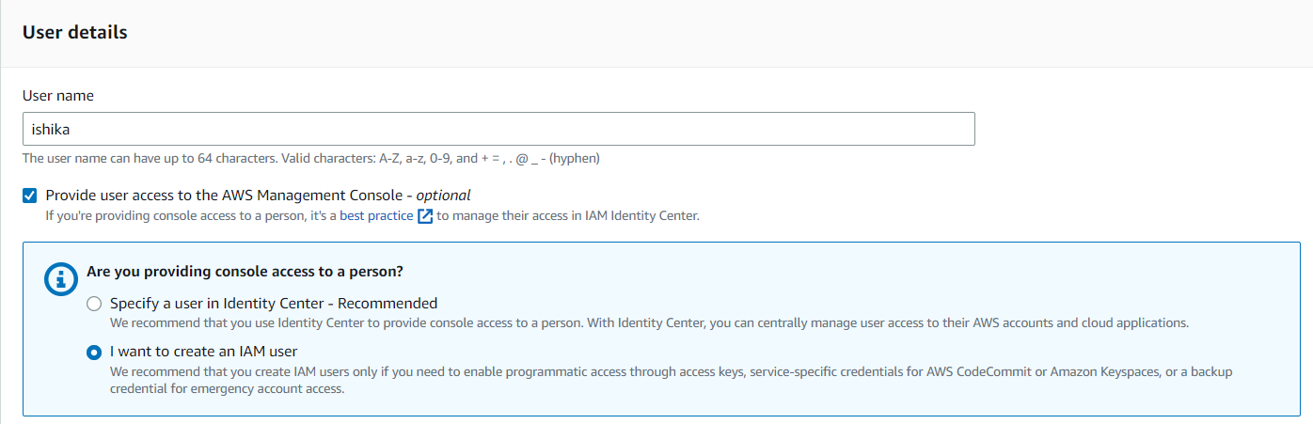

4. Select the type of access this user will have.

• Select **Enable console access**. This creates a password for the new user.

• **Custom password** – The user is assigned the password that you type in the box.

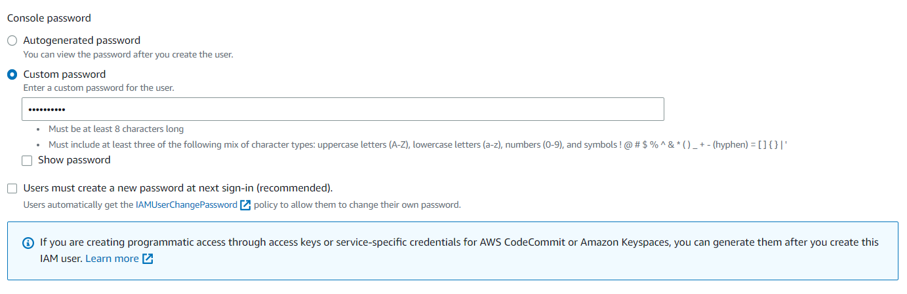

5. Uncheck Users must create a new password at next sign-in (recommended)

6. Choose **Next.**

7. On the **Set permissions** page, specify how you want to assign permissions to this set of new users. Choose **Add User to Group.**

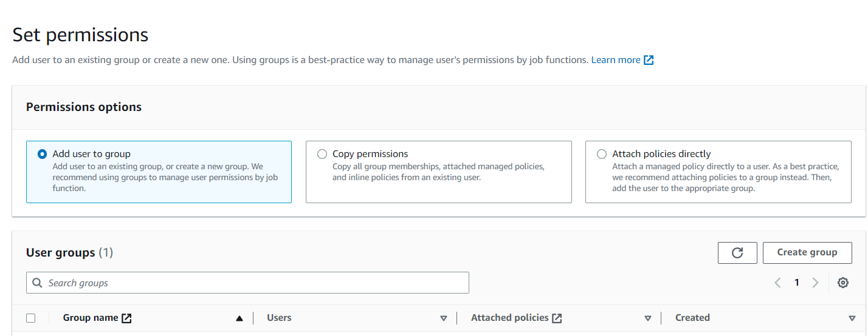

* Choose **Create group** to create a new group.
* Give the **User Group Name**
* Give the required **Permission Policies**
* Click Create **User Group**

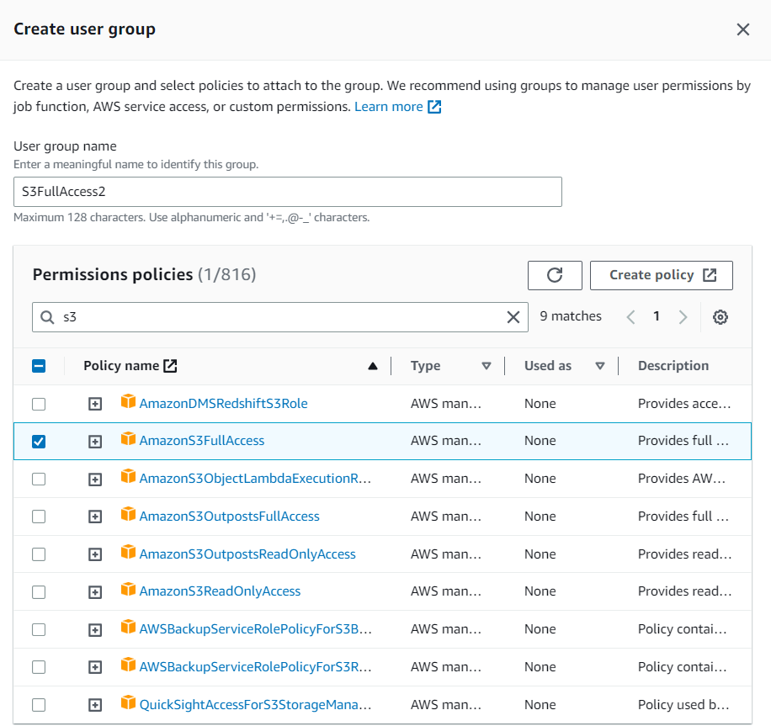

8. Check the Group and Choose **Next**.

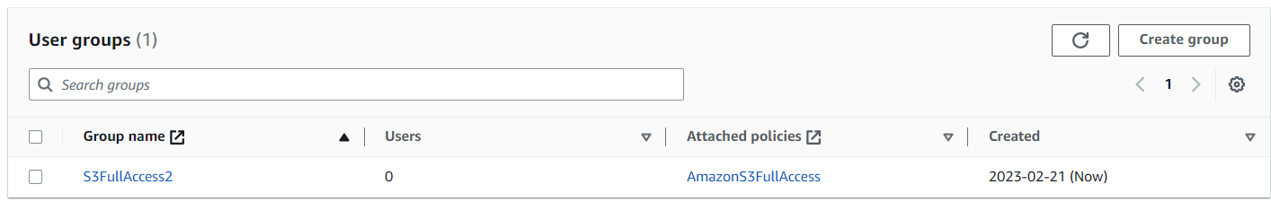

9. On the **Review and create** page, after reviewing choose **Create user**.

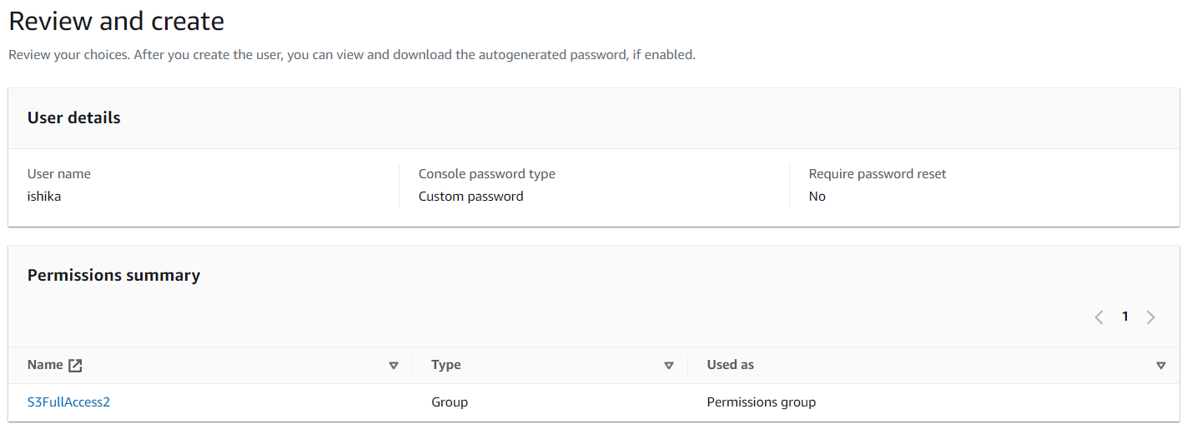

10. To save the password, choose **Download .csv** and then save the file to a safe location.

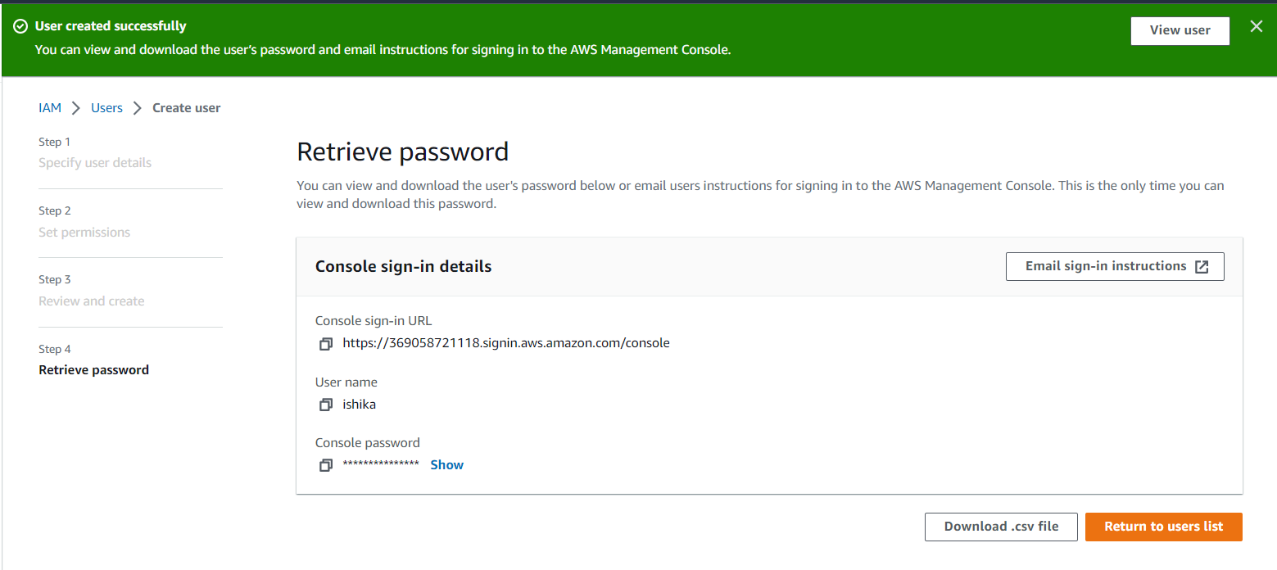

11. Provide the user with their **credentials**.

12. **New IAM User** is being created with **S3 Full Access**.